H.T No
Regulations:
A20

Sreenidhi Institute of Science and Technology
(An Autonomous Institution)
Code No: 8AC42 Date: 05-Nov-2021 (FN)

B.Tech I-Year I- Semester External Examination, Oct/Nov-2021 (Supplementary)
ELECTRICAL CIRCUITS AND NETWORK ANALYSIS (ECM)

Time: 3 Hours Max.Marks:70

Note: a) No additional answer sheets will be provided.
b) All sub-parts of a question must be answered at one place only, otherwise it will not be valued.
c) Missing data can be assumed suitably.

ANSWER ANY 5 OUT OF 8 QUESTIONS. EACH QUESTION CARRIES 14 MARKS.

Bloom's Cognitive Levels of Learning (BCLL)

Remember | L1 | Apply | L3 | Evaluate | L5
Understand | L2 | Analyze | L4 | Create | L6

 |  |  | BCLL | CO(s) | Marks
1. | a) | In the circuit shown below, determine the current through 2Ω resistor and the total current delivered by the battery 10V. Use Kirchhoff’s laws.  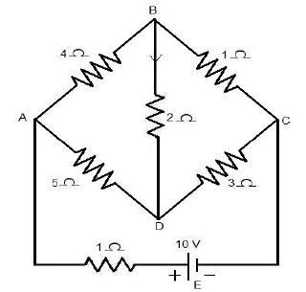 | L4 | CO1 | [7M]
 | b) | Find the current in the 4Ω resistor using nodal analysis.  6Ω  10V  5Ω  3Ω  4Ω  5V  2Ω | L4 | CO1 | [7M]
2. | a) | In a series circuit containing a pure resistance and a pure inductance, the current and voltage are expressed as i(t) = 5 sin (314t + 2π/3) and V(t) = 15 sin (314t+5π/6). Find the impedance of the circuit, resistance and inductance of the circuit | L4 | CO2 | [7M]
 | b) | A Series R-L-C Circuit is resonant at 1 megacycles/sec. Its bandwidth is 5000 cycles per second and input impedance at resonance is 50Ω. Find R, L and C. | L3 | CO2 | [7M]
3. | a) | In mutually coupled coils, the voltage drop across one coil, from the dotted terminal to the undotted terminal, equals M times the derivative of the current through the other coil, from the dotted terminal to the undotted terminal. Explain. | L5 | CO3 | [7M]
 | b) | A coil having an inductance of 100mH is magnetically coupled to another coil having an inductance of 900mH. The coefficient of coupling between the coils is 0.45. Calculate the equivalent inductance if the two coils are connected in i) series aiding ii) series opposing iii) parallel aiding and iv) parallel opposing. | L3 | CO3 | [7M]
4. | a) | Find the Norton’s equivalent circuit across a-b for the network shown in below figure.  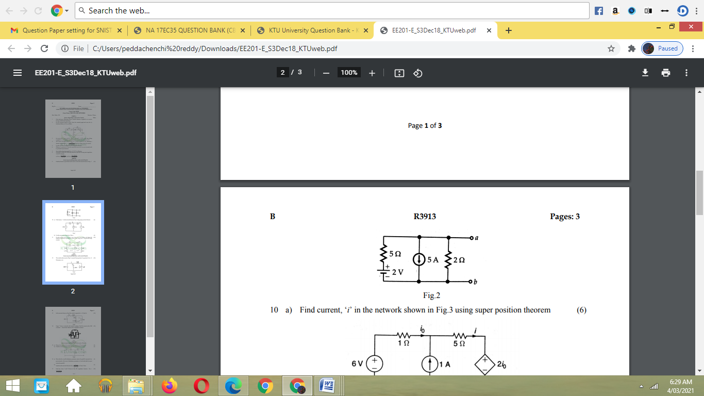 | L4 | CO4 | [7M]
 | b) | Find the current i in the network shown. below using Superposition theorem  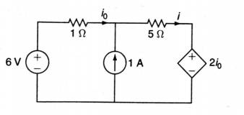 | L4 | CO4 | [7M]
5. | a) | Find the transmission parameters of the below network  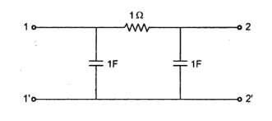 | L4 | CO5 | [7M]
 | b) | What are h- parameters? Draw the equivalent circuit of a two port network with h- parameter representation. | L2 | CO5 | [7M]
6. | a) | Find the response of RC network with AC excitation using Laplace transform method. | L2 | CO6 | [7M]
 | b) | The circuit shown in figure consists of resistance, inductance, and capacitance in series with a 200 V constant source. When the switch is closed at t = 0. Find the transient current using differential equation approach.  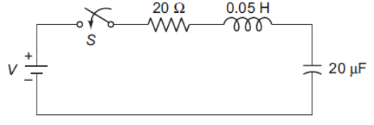 | L3 | CO6 | [7M]
7. | a) | An ideal voltage source whose internal resistance r_{s}=0 cannot be transformed into a current source. Explain. | L5 | CO1 | [5M]
 | b) | Find the effective value of the periodic voltage waveform shown in the below figure  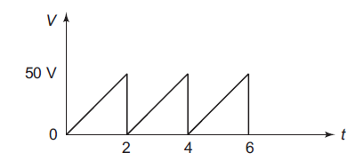 | L3 | CO2 | [5M]
 | c) | Find the equivalent reluctance of a closed magnetic circuit consisting of three magnetic cores. | L3 | CO3 | [4M]
8. | a) | State and prove the Maximum Power Transfer Theorem when the load resistance is equal to the magnitude of source impedance. | L2 | CO4 | [5M]
 | b) | Show that the overall admittance parameter matrix for parallel connected two port network is the sum of admittance parameters of each individual two port network in parallel. | L3 | CO5 | [5M]
 | c) | Briefly explain the importance of initial conditions. | L2 | CO6 | [4M]
-- 00 -- 00 –

